Cadorna, Joeffrey July 1, 2025
BSCS – 1 (CBM)
MP2 : Improved MP1 Calculator (with binary and decimal)
- Code

class Calculator:
def my_oprt(self, a, b, choice):
if choice == 1:
return a + b
elif choice == 2:
return a - b
elif choice == 3:
return a * b
elif choice == 4:
if b != 0:
return a / b
else:
return "Error: Division by zero!"
elif choice == 5:
if b != 0:
return a % b
else:
return "Error: Division by zero!"
else:
return "Invalid operation"

def show_menu(self):
print("**********************")
print("Welcome to Mr. Calculator")
print("1 - Add\n2 - Subtract\n3 - Multiply\n4 - Divide\n5 - Remainder\n6 - Exit")

def decimal_to_binary(n):
if n == 0:
return "0"
binary = ""
while n > 0:
binary = str(n % 2) + binary
n //= 2
return binary

def main():
while True:
print("Select Base System:")
print("1 - Binary")
print("2 - Decimal")

try:
base_choice = int(input("Enter base system (1 or 2): "))
if base_choice not in (1, 2):
print("Invalid choice. Please enter 1 or 2.\n")
continue
except ValueError:
print("Invalid input. Please enter a number.\n")
continue

calc = Calculator()
calc.show_menu()

try:
choice = int(input("Enter your operation choice: "))
except ValueError:
print("Invalid input. Please enter a number.\n")
continue

if choice == 6:
print("Goodbye!")
break # Exit the entire program

if 1 <= choice <= 5:
try:
if base_choice == 1:
bin_a = input("Enter first binary number: ")
bin_b = input("Enter second binary number: ")
a = int(bin_a, 2)
b = int(bin_b, 2)

result = calc.my_oprt(a, b, choice)

if isinstance(result, str):
print(result)
elif isinstance(result, float):
if result.is_integer():
print("Result (in binary):", decimal_to_binary(int(result)))
else:
print("Result (in decimal):", round(result, 6))
else:
print("Result (in binary):", decimal_to_binary(result))
else:
a = float(input("Enter first number: "))
b = float(input("Enter second number: "))
result = calc.my_oprt(a, b, choice)
print("Result:", result)

except ValueError:
print("Invalid input. Please enter valid numbers.")
except Exception as e:
print("An error occurred:", str(e))
else:
print("Invalid operation choice. Please select between 1 and 6.")

print("\n--- Returning to base system selection ---\n")

if __name__ == "__main__":
main()

- Programiz Link: https://www.programiz.com/online-compiler/1zozAqrjc2Bqz
Note: May require refreshing if output doesn’t show immediately

- Narrative
For this activity, we or rather I have just modified and improve our MP1 by adding an option for the user to perform or select what number system they wish to execute be it either binary or decimal.
For the main part of this narrative. I first reused the code from my MP1 starting from the Calculator class. And then the method which is my_oprt which basically does the arithmetic or operations based on the user’s operation that they choose of, in this case it is declared as the choice in line 2 (self, a, b, choice). Then, once the user chooses either 4 and/or 5, it checks for division by zero and returns an error if needed.
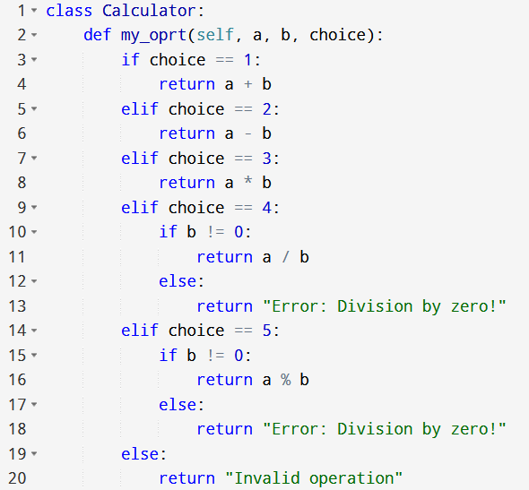
Second, the def show_menu(self) and the following, just prints a menu that tells the user what number corresponds to each operation assigned per number.
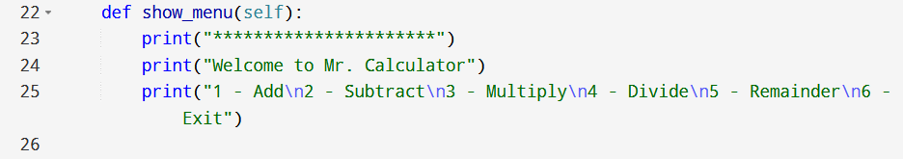
Then, for the decimal_to_binary(n) this converts a decimal number to binary, but only for integers.
For example, n = 5:
5 % 2 = 1 (which is the rightmost bit)
5 // 2 = 2
2 % 2 = 0 (which is the next bit)
2 // 2 = 1
1 % 2 = 1 (next bit)
With the result of it being 101, therefor 5 is equals to 101 in terms of binary code.
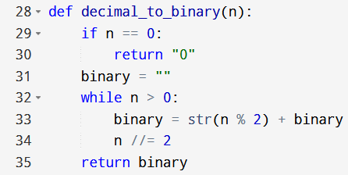
Moreover, we then have the main() Function, which handles all the user interaction and runs in an infinite loop (in this case I use the (while True:), which allows the user to keep using the calculator until they choose the option to exit.
Now inside of main() there’s a few parts, and I’ll break down each one of them. First, is the Base System Selection, that then prompts or allow the user to choose a base system of their choice if it’s Binary or Decimal.
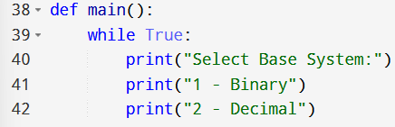

That then I validate the input using:
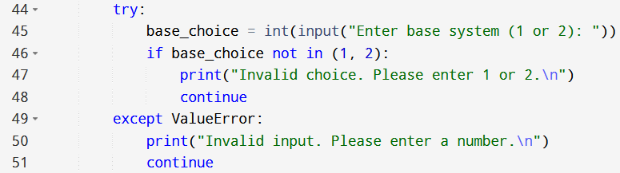
Second, the Operation Menu. Which creates an object of the Calculator class and calls the show_menu() to show the operations that can be chosen by the user.
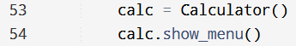
Third, Getting the User’s Operation, where if choice == 6, then it exits the program via the break.
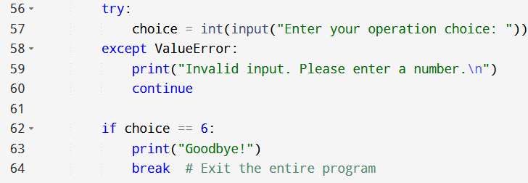
Lastly, Getting the Inputs and Performing the Operation. If Binary Mode (base_choice == 1) which then converts the binary strings to decimal numbers. The If Decimal Mode (base choice == 2) then the inputs are floated directly.
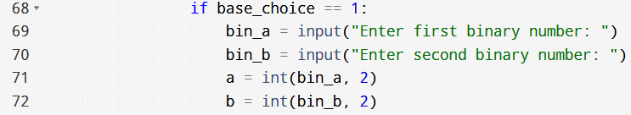

Then for the Show Result, it converts it to binary (if base is binary) or otherwise it rounds the decimal to 6 digits.
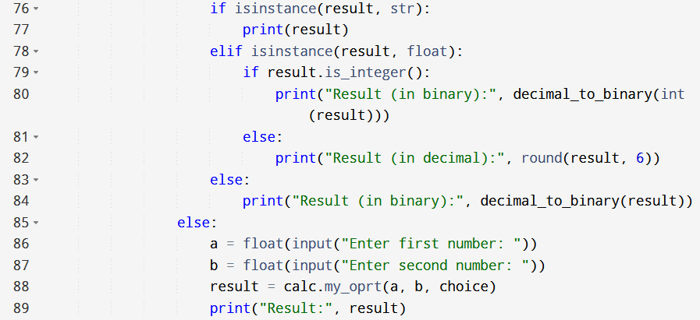
Additionally, there is also the ValueError and Exception for the Error handling of the user’s input.
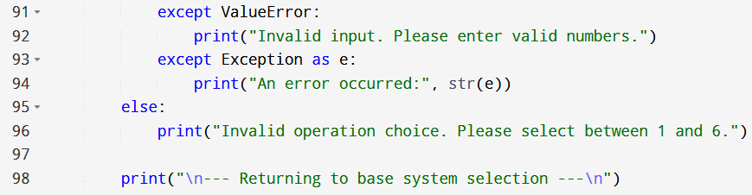
Furthermore, if _name_==”main_” ensures that the main() function only runs when the script is executed directly.
And here’s a few snippets of the output of the program in conjunction with the error handling:
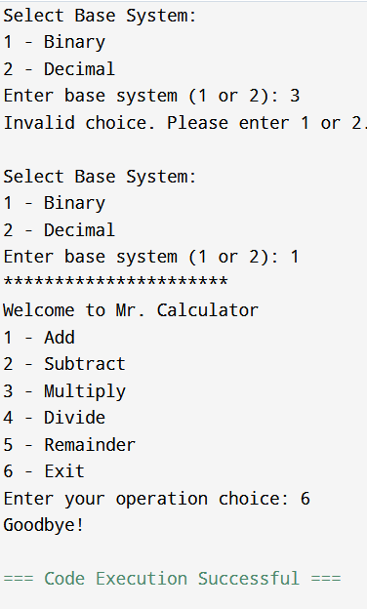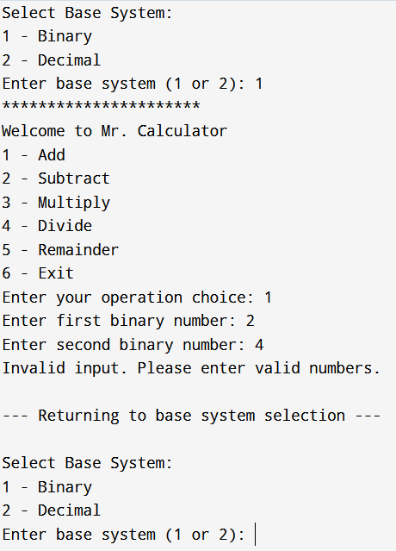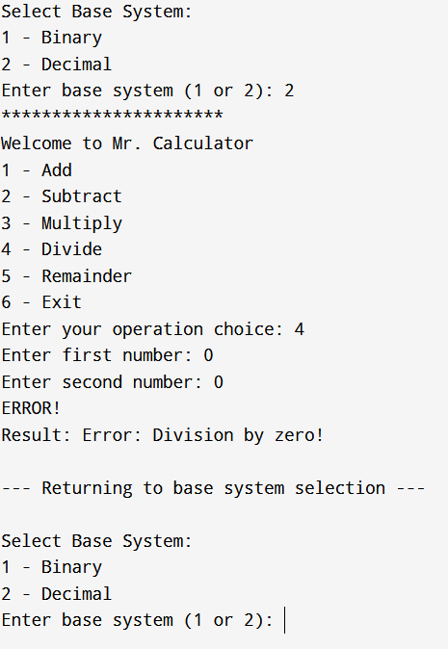
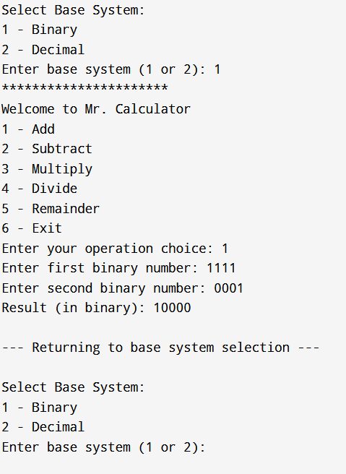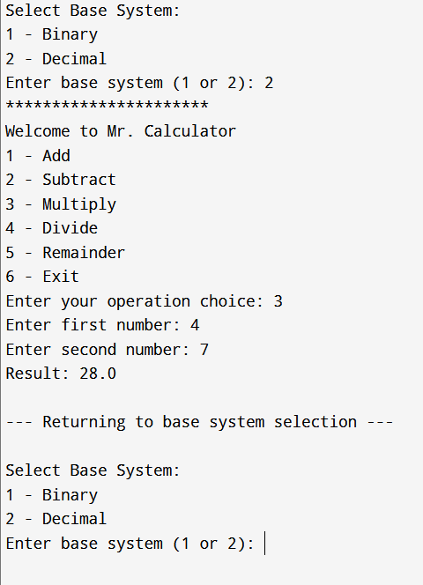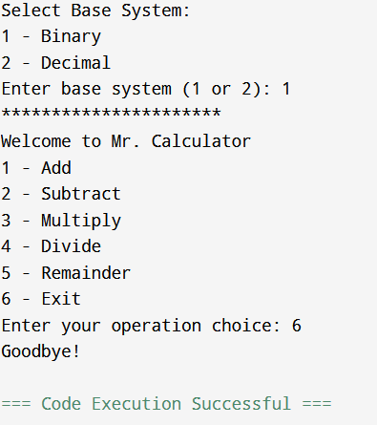

To conclude, this calculator program we or rather I have done for our Machine Problem 2, with the added modifications and improvement on it, that makes use of the ability to choose a number system upon running the program whether it’s binary or decimal calculation, the use of conditional logic, loops, as well as the manual implementation of the binary conversion, and amongst others.

